**Slope Formula**

 or 

*This formula can be used to find the slope of a line, the steepness of a line, and the rate of change.

1. What is the slope of the line containing the points  and ?

2. In the diagram below, what is the slope of the line passing through points *A* and *B*?

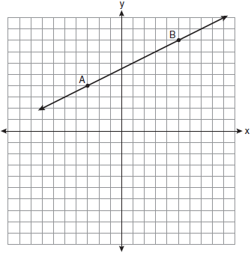

3. What is the slope of the line passing through the points (2, -1) and (2, 5)

**Types of Slope:**

a)

b)

c)

d)

What will the slope of a ***horizontal line*** always be?

What will the slope of a ***vertical line*** always be?